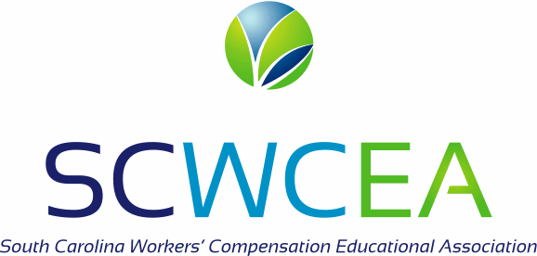 SCWCEA Inspiration Award Application
This application must be received by the SCWCEA office no later than June 1 in order to be considered.
The South Carolina Workers’ Compensation Educational Association (SCWCEA) is accepting applications to acknowledge the successes of an injured worker and their workers’ compensation team. The recipient(s) will be recognized during the SCWCEA’s Annual Educational Conference in the fall.

Any current member in good standing with the SCWCEA may nominate a candidate by submitting an application and supporting documents to: SCWCEA
PO Box 1496
Columbia, SC 29202
Fax: 803.429.4275
Email: alexa@scwcea.org

There is no requirement that the award be bestowed annually and no more than one award will be given in a single year.
All recipients must receive a strong endorsement by the SCWCEA Inspiration Award Committee and Board of Directors.
REQUIREMENTS

All candidates:
- Nominations must be submitted by an active SCWCEA member.
- Injured Worker must have been a part of the SC Workers’ Compensation system
- Injured Worker has consented to nomination of this award

APPLICATION FORM FOR SELECTION

Name of Injured Worker

Name of Member submitting application

Organization of member

Address City State Zip

Phone Email

- Was the injured worker’s case handled by the SC WCC? Yes No
Year of Injury_____________________________
Please list names and affiliations of professionals involved in the care and treatment of this injured
worker_____________________________________________________________________________________

__________________________________________________________________________________________

- Were there innovative approaches to treatment? Yes No If so, please explain
__________________________________________________________________________________________

__________________________________________________________________________________________

Please attach additional sheets if needed.

- Please provide a brief overview of the accident, severity of injury, obstacles that were overcome and how they were handled, accommodations made by the employer, actions taken by employer to facilitate recovery from injury and return to work, treatment paths taken during care by physician as well as any significant efforts made by adjusters, nurse case managers, attorneys, or other service providers.

______________________________________________________________________________________________

______________________________________________________________________________________________

______________________________________________________________________________________________

______________________________________________________________________________________________

______________________________________________________________________________________________

______________________________________________________________________________________________

______________________________________________________________________________________________

______________________________________________________________________________________________

______________________________________________________________________________________________

______________________________________________________________________________________________

______________________________________________________________________________________________

______________________________________________________________________________________________

______________________________________________________________________________________________

______________________________________________________________________________________________

______________________________________________________________________________________________

______________________________________________________________________________________________

______________________________________________________________________________________________

Nominated by:___________________________________________________ Date:_________________________

Phone:____________________________________________Email:_______________________________________
If the Inspiration Award Committee or Board has additional questions, you may be contacted.

